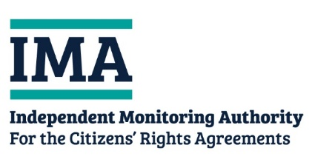
Consent Form

Respondent Personal details (the person that the survey response relates to)
Title
Full name
Date of Birth
Email
Address

Declaration
☐ I confirm the representative below has the authority to act on my behalf.
☐ The information I have provided is correct to the best of my knowledge.
☐ I have read and understand the IMA Privacy Notice.
☐ I agree that the IMA may contact my representative to discuss the response further.

Signature
Date

Representative details (the person completing the survey on behalf of the person above)
Title
Full name
Date of Birth
Email
Address
Relationship to respondent
(e.g. Friend, guardian)

Declaration
☐ I confirm I have authority to act on behalf of the respondent.
☐ The information I have provided is correct to the best of my knowledge.
☐ I have read and understand the IMA Privacy Notice.
☐ I agree that the IMA may contact me to discuss the response further.

Signature
Date

